Basic Design Phase

Target Audience

This website is targeting all people over the world such as family, couple, even people who like to travel alone. The age range is 16-70 years old. Since madams tussauds have a lot of different statue covering all the age group.

Aims

The aim of this website is to let more people know that there is also Madams Tussauds in Hong Kong, and to make more people feel interest about Hong Kong.

Objectives

To show and let people know where kind of statue is there and the attraction of Hong Kong. Making more people over the world would like to come and visit Hong Kong.

For this website all information/ pictures are gathered from:

<http://www.discoverhongkong.com/eng/see-do/highlight-attractions/index.jsp>

<http://www.discoverhongkong.com/ca/see-do/highlight-attractions/top-10/index.jsp>

<http://www.tommyooi.com/hongkong-attractions/>

And Google Image.

Sites Evaluated

<http://www.discoverhongkong.com/eng/see-do/highlight-attractions/index.jsp>

This website is a tourist site, it also show information about Hong Kong attractions. Overall I liked the colour scheme but I think the navigation bar is too messy when there is two bar overlapping each other. It would be better if it is a sub navigation bar on the side.

<http://www.tommyooi.com/hongkong-attractions/>

This website is also a tourist site, I think this site have a clear view of the information but the colour scheme is too simple as there is only a white background normally if it is a information site it will be ok but as this site is a tourist site I think using better colour scheme can make users more attracted to the place.

<http://www.virtualtourist.com/travel/Asia/Hong_Kong/Things_To_Do-Hong_Kong-TG-C-1.html>

this website also have a plain colour scheme but it display more images rather then words to keep users eyes on the page. I really like the map on the right side as it popup and show where is the attraction is. It also have a simple rating layout so if user just want to browser high ratings they do not have to go through each one.

Business Requirements:

This website is to inform travellers about the famous Madame Tussauds is also opened in Hong Kong. To show the attraction and what is inside the Madame Tussauds that make it different from all the ones around the world. This website also show other attraction in Hong Kong.

Inside this website It will tell travellers the open times, price. The important thing is the local statues which make it different from other Madame Tussauds such as "Sparkling Club" hosted by Sandra Ng. and Jacky chan. This website also shows other attractions such as Hong Kong Disneyland, Buddha and airport.

Technical Requirement

For technical requirements I have to make sure the website is compatible with different browsers because some browsers take different code differently. Now day’s different user might user different browsers so is really important to keep the website working with most of the browsers. This problem can be spotted by using multi browser when creating the site to see each effect of code to the web page in each browser.

Another thing is the speed of the website. A lot of website uses too much graphic and high resolution pictures which make the speed of downloading the content take longer. My aim for this website is every page should be opened within seconds. This can be achieved by using lower resolution pictures.

User Requirements

To make the site viewable and accessible I will use a red colour navigation bar and using a colour background on each heading to indelicate what page the user is on. Also to not confuse the user by having a huge navigation bar, I will create another side navigation bar to show sub content.

To make it more easy to use I will use new tab for all external links as it will not lose the page you are browsing and allowing user to come back to where they stopped.

This website is targeting audience is 20 to 50 years old travellers and families. As the Madame Tussauds has different types of statue the audience range increase as there is fantasy for teenage and historical for elder.

Design requirements

As the Madame Tussauds always have a feeling of elegant, my design will be using a red curtain background to make the website more elegant like welcoming the user to browse this website.

To fit on users screen I will centre the content and use scroll when the content is overflowing so that even if the user’s screen is too small and the content still will be readable by scrolling.

To make my navigation bar clearer I will do a hover background colour, which mean when user’s curser is over it the website will show clearly what the user about to click on is.

Portfolio Content

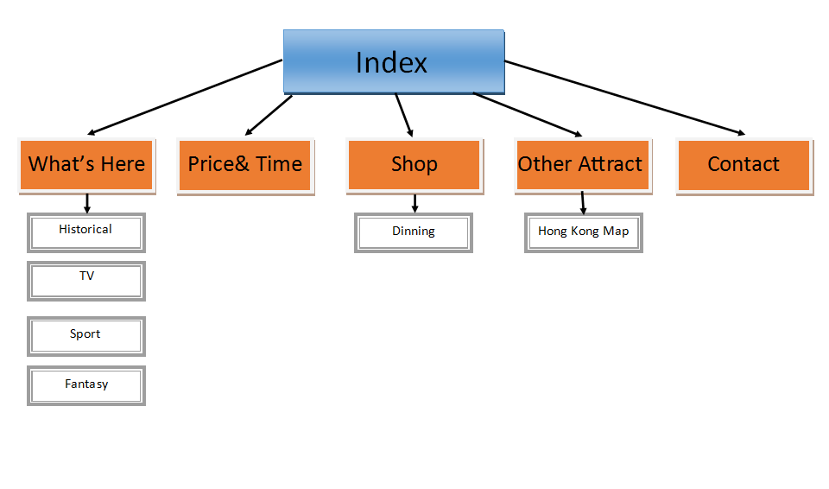

**What’s here:**

Shows the statue in the Hong Kong Madame Tussauds.

Historical: Statue relate to historical people

TV: Statue relate to TV Stars

Sport: Statue relate to famous Sport Players

Fantasy: Statue relate to Movie heroes

**Price & Time:**

Showing opening time and the price for the tickets.

**Shop:**

Showing the shop inside Madame Tussauds.

Dinning: Showing and linking the peak restaurant.

**Other Attractions:**

Display other attractions that worth to go in Hong Kong.

Hong Kong Map: to show an image map of Hong Kong and linking external link to the attractions

**Contact:**

Showing contact method such as phone number, comment, emails.

Gathering Content

**What’s here:**

**Historical:**

**Elizabeth II** (*Elizabeth Alexandra Mary*; born 21 April 1926)[[b]](http://en.wikipedia.org/wiki/Elizabeth_II#cite_note-birthday-4) is the Queen of [16](http://en.wikipedia.org/wiki/Commonwealth_realm) of the 53 [member states](http://en.wikipedia.org/wiki/Member_states_of_the_Commonwealth_of_Nations) in the [Commonwealth of Nations](http://en.wikipedia.org/wiki/Commonwealth_of_Nations). She is [Head of the Commonwealth](http://en.wikipedia.org/wiki/Head_of_the_Commonwealth) and [Supreme Governor of the Church of England](http://en.wikipedia.org/wiki/Supreme_Governor_of_the_Church_of_England).

Upon her accession on 6 February 1952, Elizabeth became Head of the Commonwealth and [queen regnant](http://en.wikipedia.org/wiki/Queen_regnant) of seven independent Commonwealth countries: the [United Kingdom](http://en.wikipedia.org/wiki/United_Kingdom), [Canada](http://en.wikipedia.org/wiki/Canada), [Australia](http://en.wikipedia.org/wiki/Australia), [New Zealand](http://en.wikipedia.org/wiki/New_Zealand), [South Africa](http://en.wikipedia.org/wiki/Union_of_South_Africa), [Pakistan](http://en.wikipedia.org/wiki/Dominion_of_Pakistan) and [Ceylon](http://en.wikipedia.org/wiki/Dominion_of_Ceylon). [Her coronation](http://en.wikipedia.org/wiki/Coronation_of_Queen_Elizabeth_II) the following year was the first to be televised. From 1956 to 1992, the number of her realms varied as territories gained independence and some realms became republics. Today, in addition to the first four of the aforementioned countries, Elizabeth is Queen of [Jamaica](http://en.wikipedia.org/wiki/Jamaica), [Barbados](http://en.wikipedia.org/wiki/Barbados), [the Bahamas](http://en.wikipedia.org/wiki/The_Bahamas), [Grenada](http://en.wikipedia.org/wiki/Grenada), [Papua New Guinea](http://en.wikipedia.org/wiki/Papua_New_Guinea), [Solomon Islands](http://en.wikipedia.org/wiki/Solomon_Islands), [Tuvalu](http://en.wikipedia.org/wiki/Tuvalu), [Saint Lucia](http://en.wikipedia.org/wiki/Saint_Lucia), [Saint Vincent and the Grenadines](http://en.wikipedia.org/wiki/Saint_Vincent_and_the_Grenadines), [Belize](http://en.wikipedia.org/wiki/Belize), [Antigua and Barbuda](http://en.wikipedia.org/wiki/Antigua_and_Barbuda), and [Saint Kitts and Nevis](http://en.wikipedia.org/wiki/Saint_Kitts_and_Nevis). She is the world's oldest reigning monarch as well as Britain's [longest-lived](http://en.wikipedia.org/wiki/List_of_British_monarchs_by_longevity) and [second longest-reigning](http://en.wikipedia.org/wiki/List_of_monarchs_in_Britain_by_length_of_reign#Overall) head of state.

Elizabeth was born in London and educated privately at home. Her father acceded to the throne as [George VI](http://en.wikipedia.org/wiki/George_VI) on the [abdication](http://en.wikipedia.org/wiki/Edward_VIII_abdication_crisis) of his brother [Edward VIII](http://en.wikipedia.org/wiki/Edward_VIII) in 1936, from which time she was the [heir presumptive](http://en.wikipedia.org/wiki/Heir_presumptive). She began to undertake public duties during the [Second World War](http://en.wikipedia.org/wiki/Second_World_War), in which she served in the [Auxiliary Territorial Service](http://en.wikipedia.org/wiki/Auxiliary_Territorial_Service). In 1947, she married [Prince Philip, Duke of Edinburgh](http://en.wikipedia.org/wiki/Prince_Philip,_Duke_of_Edinburgh), with whom she has four children: [Charles](http://en.wikipedia.org/wiki/Charles,_Prince_of_Wales), [Anne](http://en.wikipedia.org/wiki/Anne,_Princess_Royal), [Andrew](http://en.wikipedia.org/wiki/Prince_Andrew,_Duke_of_York), and [Edward](http://en.wikipedia.org/wiki/Prince_Edward,_Earl_of_Wessex).

Her Majesty Queen Elizabeth II is dressed in a re-creation of the Swarovski crystal covered dress that was worn for her official Diamond Jubilee Portrait.

**TV:**

The daughter of Ng Kam-chuen, Ng was born in Hong Kong, where she attended [St. Stephen's Girls' College](http://en.wikipedia.org/wiki/St._Stephen%27s_Girls%27_College). Encouraged by her parents, she began her entertainment career at the age of 16. She is most known through her comic roles, where she often pokes fun at her plain looks. She has frequently collaborated with [Stephen Chow](http://en.wikipedia.org/wiki/Stephen_Chow), notably in [*all for the Winner*](http://en.wikipedia.org/wiki/All_for_the_Winner), [*Magnificent Scoundrels*](http://en.wikipedia.org/wiki/Magnificent_Scoundrels) and [*Royal Tramp*](http://en.wikipedia.org/wiki/Royal_Tramp), among others. In a career spanning over 20 years, she has filmed over 100 films and TV shows. She co-hosted *Club Sparkle*, a celebrity talk show, during the first half of 2009 and is also a radio personality for [CRHK](http://en.wikipedia.org/wiki/CRHK). Her radio program, *He She Hit* ,aired from 12am to 2am on Monday to Friday.

**Sport:**

Liu is one of China's most commercially successful athletes and has emerged as a [cultural icon](http://en.wikipedia.org/wiki/Cultural_icon). He is the only male athlete in history to have achieved the "triple crown" in the event of 110-metre hurdles: World Record Holder, World Champion and Olympic Champion. He was the favourite to win another gold in the [110 metre hurdles](http://en.wikipedia.org/wiki/Athletics_at_the_2008_Summer_Olympics_%E2%80%93_Men%27s_110_metres_hurdles) at the [Beijing Olympics](http://en.wikipedia.org/wiki/China_at_the_2008_Summer_Olympics), but he had to withdraw from competition at the last moment after a false start and aggravation to a previously unrevealed injury. Again a gold medal favourite in the [110 metre hurdles](http://en.wikipedia.org/wiki/Athletics_at_the_2012_Summer_Olympics_%E2%80%93_Men%27s_110_metres_hurdles) at the [London Olympics](http://en.wikipedia.org/wiki/China_at_the_2012_Summer_Olympics) he pulled his Achilles tendon attempting to clear the first hurdle in the heats. On April 7, 2015, he made a retirement announcement on his Sina Weibo. He would end his sport career officially.

**Fantasy:**

Tony Stark is injured by a booby trap and captured by enemy forces led by [Wong-Chu](http://en.wikipedia.org/wiki/Wong-Chu). Wong-Chu orders Stark to build weapons, but Stark's injuries are dire and shrapnel is moving towards his heart. His fellow prisoner, [Ho Yinsen](http://en.wikipedia.org/wiki/Ho_Yinsen), a [Nobel Prize](http://en.wikipedia.org/wiki/Nobel_Prize)-winning [physicist](http://en.wikipedia.org/wiki/Physicist) whose work Stark had greatly admired during college, constructs a [magnetic](http://en.wikipedia.org/wiki/Magnetism) chest plate to keep the shrapnel from reaching Stark's heart, keeping him alive. In secret, Stark and Yinsen use the workshop to design and construct a [suit](http://en.wikipedia.org/wiki/Iron_Man%27s_armor) of [powered armor](http://en.wikipedia.org/wiki/Powered_exoskeleton), which Stark uses to escape. But during the escape attempt, Yinsen sacrifices his life to save Stark's by distracting the enemy as Stark recharges. Stark takes revenge on his kidnappers and heads back to rejoin the American forces, on his way meeting a wounded American [Marine](http://en.wikipedia.org/wiki/United_States_Marine_Corps) fighter pilot, [James "Rhodey" Rhodes](http://en.wikipedia.org/wiki/War_Machine).

Back home, Stark discovers that the shrapnel fragment lodged in his chest cannot be removed without killing him, and he is forced to wear the armor's chestplate beneath his clothes to act as a regulator for his heart. He must recharge the chestplate every day or else risk the shrapnel killing him. The cover for Iron Man is that he is Stark's [bodyguard](http://en.wikipedia.org/wiki/Bodyguard) and corporate mascot. To that end, Iron Man fights threats to his company, such as [Communist](http://en.wikipedia.org/wiki/Communism) opponents [Black Widow](http://en.wikipedia.org/wiki/Black_Widow_(Natalia_Romanova)), the [Crimson Dynamo](http://en.wikipedia.org/wiki/Crimson_Dynamo) and the [Titanium Man](http://en.wikipedia.org/wiki/Titanium_Man), as well as independent villains like the[Mandarin](http://en.wikipedia.org/wiki/Mandarin_(comics)), who eventually becomes his greatest enemy. No one suspects Stark of being Iron Man as he cultivates an image as a rich playboy and industrialist. Two notable members of Stark's supporting cast at this point are his personal chauffeur [Harold "Happy" Hogan](http://en.wikipedia.org/wiki/Happy_Hogan) and secretary [Virginia "Pepper" Potts](http://en.wikipedia.org/wiki/Pepper_Potts), to both of whom he eventually reveals his dual identity. Meanwhile, James Rhodes finds his own niche as Stark's personal pilot, revealing himself to be a man of extraordinary skill and daring.

**Price & Time:**

We are open daily all year round from 10am until 10pm. Last admission is at 9:45pm.

Madame Tussauds combo ticket booth at the Garden Road Peak Tram Terminus opens from 9:30am to 9:00pm.

From March 31 to April 30 2015, every regular-priced adult admission ticket or online adult admission ticket purchased from the Madame Tussauds Hong Kong official website will be entitled to free entry for up to two children (3 to 11 years old).

**Other Attractions:**

Avenue of stars, the peak, ocean park, Hong Kong Disneyland, ladies market, temple street night market, tsim sha tsui

Small Content

Small Content

Sub- Navigation

Sub- Navigation

Advertisement

Video Display

Navigation Bar

Navigation Bar

Main Content

Main Content

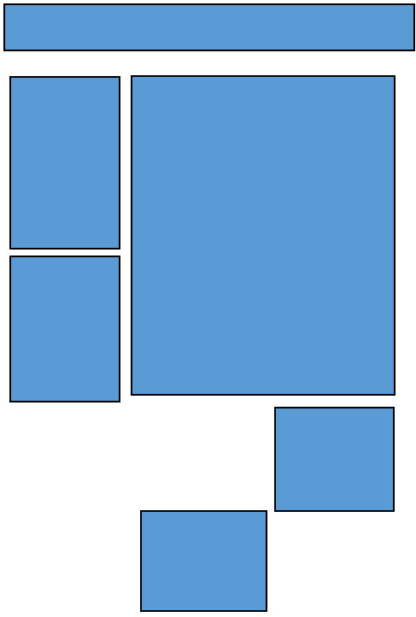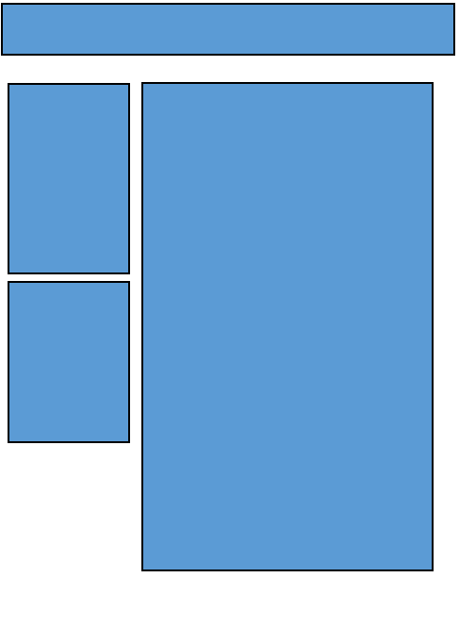

1 2

Layout 1:

In layout I will use it for the index page as I created more boxes to show more content of different parts of the website.

Layout 2:

In layout 2 I removed some boxes to increase the size of the content box in order to show more content. Ideally use for the sub headings.

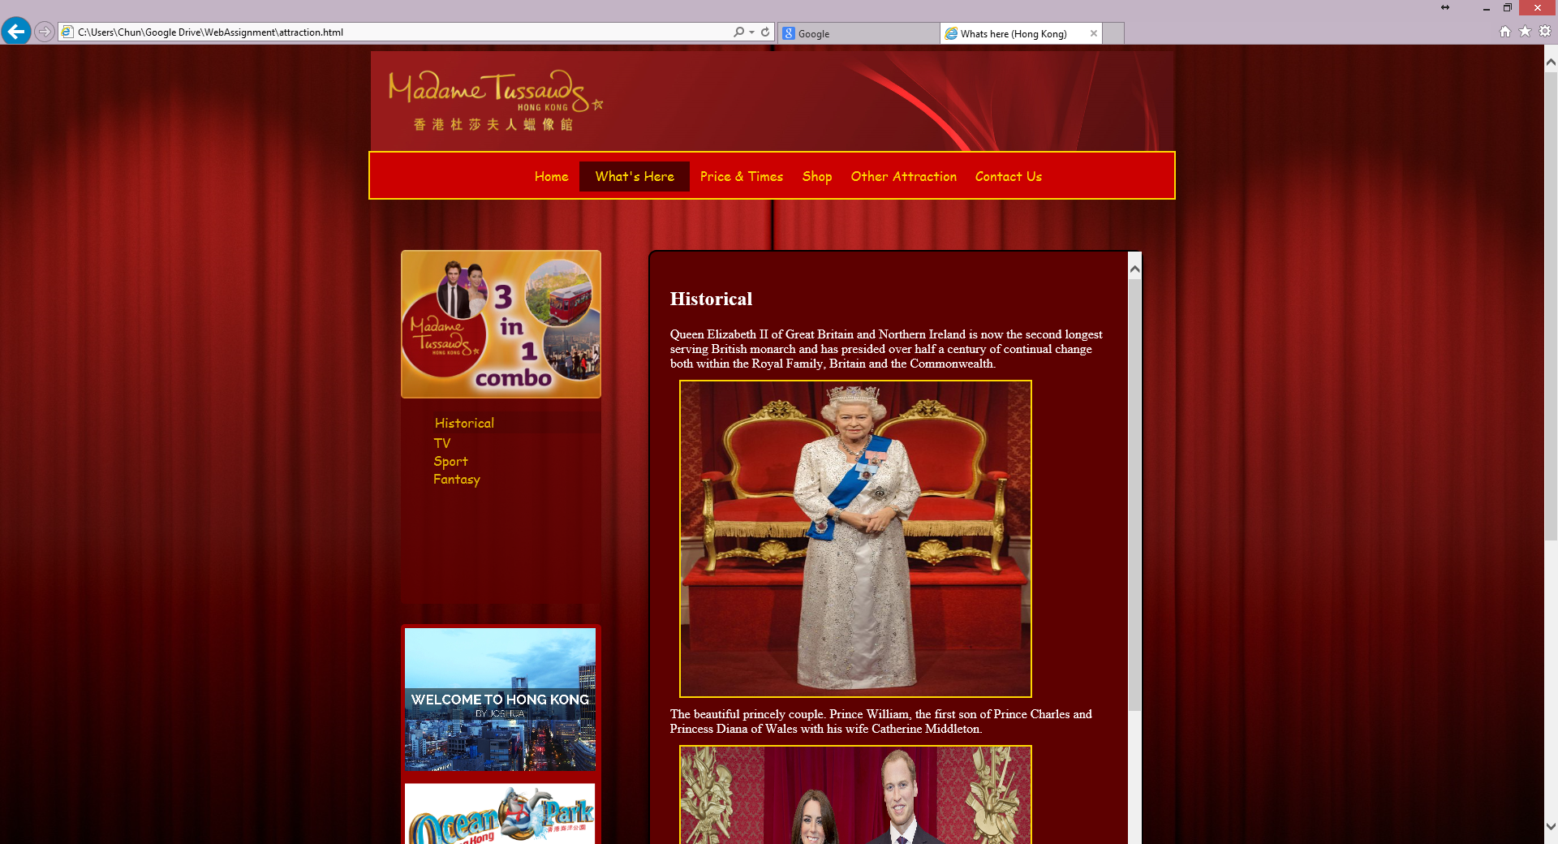

Testing website on IE

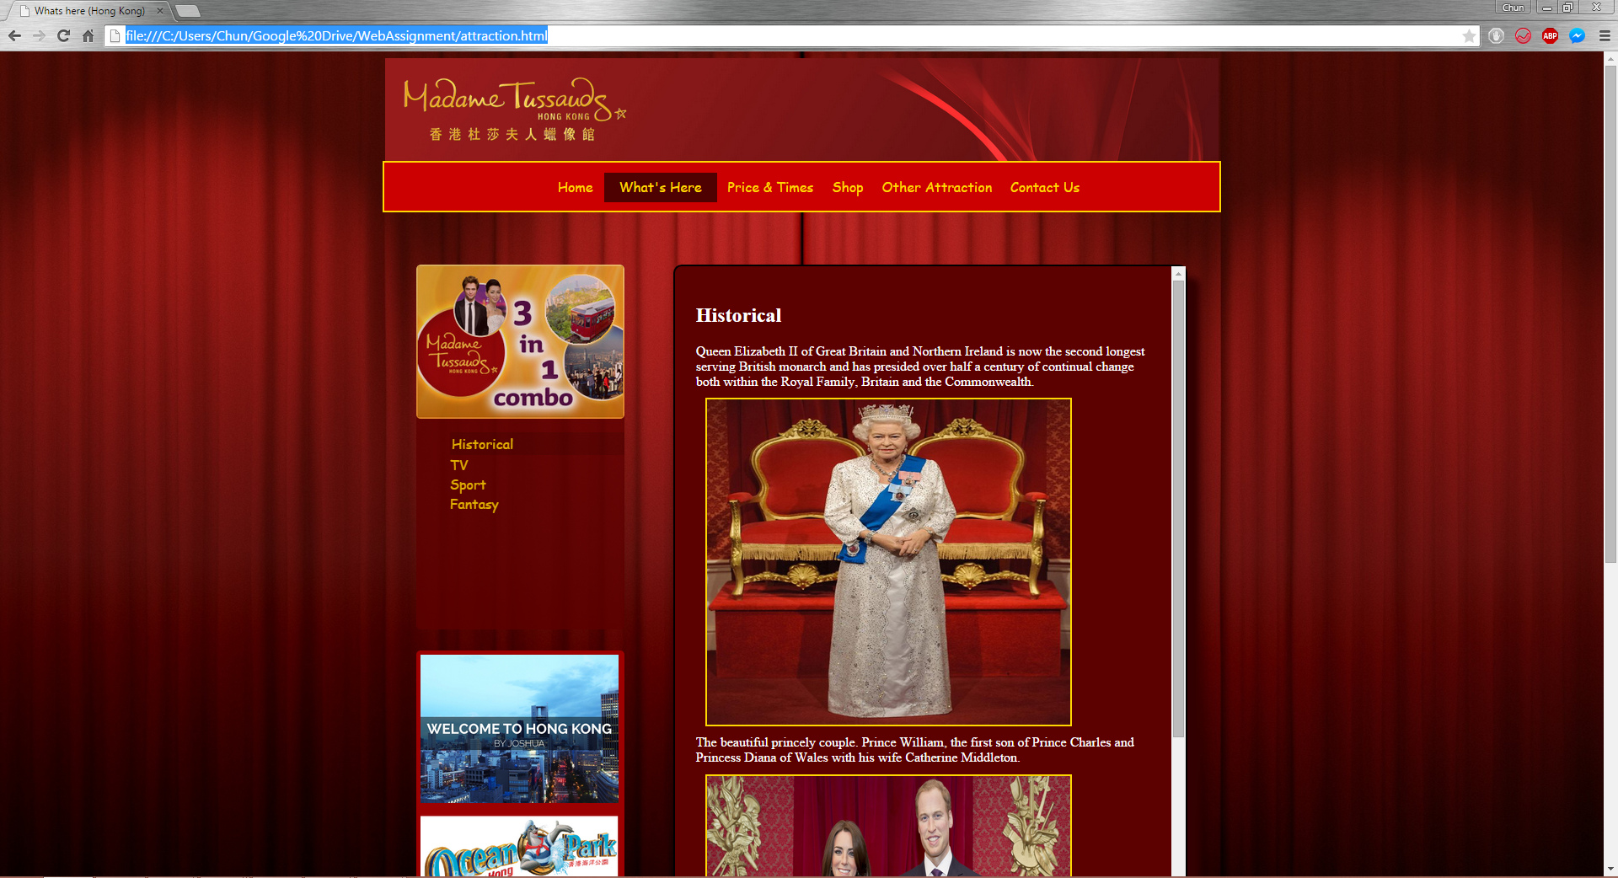

Testing Website on Google Chrome

When testing on two browsers the result was very good. As both browsers display as I designed and coded.

1 February 2015:

Today I started to find the topic of my website. I found 2 topic first is Ocean park and second is The peak and Madame Tussauds

3 February 2015:

After looking at all the picture of Ocean park it have a very nice colour of blue and was thinking to do my website with a blue theme, but I decided to do Madame Tussauds

10 February 2015:

After deciding using Madame Tussauds. I was trying to find the target audience of Madame Tussauds and what kind of people would like to come and how to maximise the targets.

14 February 2015:

I went on Google and search about Madame Tussauds and found a lot of pictures. After checking few website about Madame Tussauds I think is really worth doing this topic as not a lot of people know there is in Hong Kong.

18 February 2015:

For Madame Tussauds I was thinking to do a red colour scheme as it really suits the elegant theme of Madame Tussauds.

24 February 2015:

I was looking for the background image for the website but I don’t want the background being too eye catching as the information will be too hard to see.

28 February 2015:

After looking through the pictures, I think to use red curtain background matching the elegant and is plainer and can display the information clearly.

3 March 2015:

Today I setting up the wireframe for the homepage of the website. This was challenging as I do not want to stuff everything into the homepage and user will not be able to find the information they needed.

10 March 2015:

After doing the wireframe I started to do the html layout of the website. This wasn’t hard as it is just the simple html.

14 March 2015:

Today I started to link an external style sheet to the website. First I styled the body centred the content so the information will not be all over the page.

17 March 2015:

Today I styled the navigation bar. I used a dark red colour for the background of the navigation bar. After noticing all the layout is in fix layout which affect a lot when checking on different browser and different size screen so I decided to change to liquid layout.

20 March 2015:

After looking at the navigation bar, I was thinking it is too dark and is not eye catching. So I tried to do a golden border to make it more stand out and elegant. After the border the navigation bar is much clearer.

22 March 2015:

I decide to add in a sub navigation bar on the left side to help users with sub titles. At the advertisement bar I put in other attractions which will allow users to go directly to other attractions in Hong Kong.

27 March 2015:

After creating all the content box. I did opacity on the box so it will show the background curtains. It really make the text box more elegant and using a grey background makes the box look like having a different background.

30 March 2015:

I added in a hover background colour so user will know where exactly they are at the site. Inside the sub box I put in a form so user can login.

1 April 2015:

I used the same layout for other pages. But I delete the sub contents and make the main contents bigger as the other page will require more space to display the information.

6 April 2015:

Today I did the site map a linking all the internal webpage. I also did the image map, so it will allow user to know where attractions in Hong Kong is using a Hong Kong map.

9 April 2015:

Having all the layout done. I started to add in the content. After adding in the pictures and the text. I realise the all the content is too dark after the opacity. So I set it to less and the content is much stand out.

10 April 2015:

After the image added in. I did a gold border to make it more stand out. And adding a YouTube video of Madame Tussauds. I was having a problem with changing the youtube to liquid layout. Then I figure out that it was in the html to set the size to %. Rather than pixel.

19 April 2015:

Today I finalize the website. Checking all external links are set to new tab, so it will not replace this site which causes confusion. And adding in the top button and the copyright mark.